SIMATS ENGINEERING
ASSESSMENT TOOL III – VISUALIZATION CRITIQUE & REDESIGN
Course: Data Handling and Visualization | Code: DSA0601 | CO: CO3
Duration: 120 min | Total Marks: 100 | Reg No:
Name: | KAILASH M | 192524029

COURSE OUTCOME COVERED
CO3: Analyze time-series data, trends, associations, and uncertainty through appropriate visualization methods. (BL4) Activity Tool: Visualization Critique & Redesign Weightage: 20%

Code of Conduct:
I KAILASH M (192524029) certify that this submission is my original work and that I have adhered to the guidelines specified for this assessment. I understand that any violation of academic integrity rules will result in disciplinary action.
Signature of the student: KAILASH M
Criteria | Evaluation of Existing  Visualization  (25%) | Redesign  Strategy  (25%) | Application of Vis. Principles (20%) | Organization (15%) | Accuracy (10%) | Clarity  (5%) | Total
Q1
Q2
Q3
Q4
Q5

AT3 – Visualization Critique & Redesign
R Programming Assessment – Distribution and Proportion Visualization

QUESTION 1 – ECDF and Q-Q Plot
# ============================================================
# Q1 - DELIVERY TIME DISTRIBUTION
# ============================================================

library(ggplot2)
library(dplyr)

# Create dataset
delivery <- data.frame(
Order_ID = paste0("O", sprintf("%02d", 1:20)),
Warehouse = c(
rep("Chennai", 5),
rep("Bengaluru", 5),
rep("Hyderabad", 5),
rep("Pune", 5)
),
Delivery_Time_Hrs = c(
4, 5, 6, 7, 9,
3, 5, 6, 8, 10,
6, 7, 8, 12, 15,
4, 6, 8, 9, 22
)
)

# View data
print(delivery)

# ------------------------------------------------------------
# 1A. ORIGINAL-STYLE ECDF
# ------------------------------------------------------------

ggplot(delivery,
aes(x = Delivery_Time_Hrs,
colour = Warehouse)) +
stat_ecdf(linewidth = 1) +
labs(
title = "Original-Style ECDF of Delivery Times",
x = "Delivery Time",
y = "Cumulative Probability"
) +
theme_gray()

# ------------------------------------------------------------
# 1B. ORIGINAL-STYLE Q-Q PLOT
# ------------------------------------------------------------

ggplot(delivery,
aes(sample = Delivery_Time_Hrs)) +
stat_qq() +
labs(
title = "Original-Style Q-Q Plot",
x = "Theoretical Quantiles",
y = "Sample Quantiles"
) +
theme_gray()

# ------------------------------------------------------------
# 1C. REDESIGNED ECDF
# ------------------------------------------------------------

ggplot(delivery,
aes(x = Delivery_Time_Hrs,
colour = Warehouse)) +
stat_ecdf(linewidth = 1.2) +
scale_x_continuous(
breaks = seq(0, 25, 2),
limits = c(0, 24)
) +
scale_y_continuous(
breaks = seq(0, 1, 0.1),
limits = c(0, 1)
) +
labs(
title = "Delivery Time Distribution by Warehouse",
subtitle = "Empirical cumulative distribution function",
x = "Delivery Time (hours)",
y = "Cumulative Proportion",
colour = "Warehouse"
) +
theme_minimal(base_size = 13) +
theme(
panel.grid.minor = element_blank(),
legend.position = "right"
)

# ------------------------------------------------------------
# 1D. REDESIGNED Q-Q PLOT
# ------------------------------------------------------------

ggplot(delivery,
aes(sample = Delivery_Time_Hrs)) +
stat_qq(size = 2) +
stat_qq_line(linewidth = 1) +
labs(
title = "Q-Q Plot of Delivery Times",
subtitle = "Reference line indicates expected normal distribution",
x = "Theoretical Quantiles",
y = "Observed Quantiles"
) +
theme_minimal(base_size = 13) +
theme(
panel.grid.minor = element_blank()
)

# ------------------------------------------------------------
# 1E. Q-Q PLOT BY WAREHOUSE
# ------------------------------------------------------------

ggplot(delivery,
aes(sample = Delivery_Time_Hrs)) +
stat_qq() +
stat_qq_line() +
facet_wrap(~Warehouse) +
labs(
title = "Q-Q Plot by Warehouse",
x = "Theoretical Quantiles",
y = "Observed Quantiles"
) +
theme_minimal(base_size = 13) +
theme(
panel.grid.minor = element_blank()
)

# ------------------------------------------------------------
# Q1 INTERPRETATION
# ------------------------------------------------------------

cat("\nQ1 INTERPRETATION\n")
cat("------------------------------------\n")
cat("Pune has a very large delivery time of 22 hours, indicating a possible outlier.\n")
cat("The ECDF makes it easy to compare cumulative delivery-time distributions.\n")
cat("The Q-Q plot helps identify deviations from normality.\n")
cat("The upward deviation at the extreme end indicates right-skewness caused partly by the 22-hour Pune observation.\n")
cat("An ECDF alone is not sufficient for reliably identifying outliers.\n")
cat("It should be paired with a boxplot, Q-Q plot, or another distribution plot.\n")

QUS 1 OUTPUT:

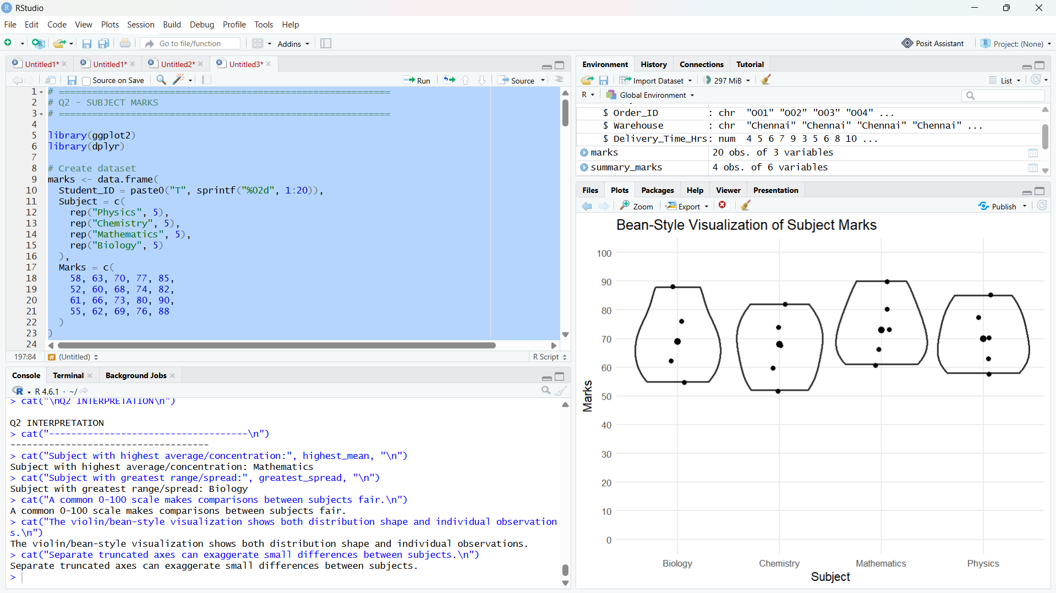

QUESTION 2 – Bean Plot / Violin Plot
# ============================================================
# Q2 - SUBJECT MARKS
# ============================================================

library(ggplot2)
library(dplyr)

# Create dataset
marks <- data.frame(
Student_ID = paste0("T", sprintf("%02d", 1:20)),
Subject = c(
rep("Physics", 5),
rep("Chemistry", 5),
rep("Mathematics", 5),
rep("Biology", 5)
),
Marks = c(
58, 63, 70, 77, 85,
52, 60, 68, 74, 82,
61, 66, 73, 80, 90,
55, 62, 69, 76, 88
)
)

print(marks)

# ------------------------------------------------------------
# 2A. ORIGINAL-STYLE SEPARATE BOXPLOTS
# ------------------------------------------------------------

par(mfrow = c(2, 2))

boxplot(
Marks ~ Subject,
data = subset(marks, Subject == "Physics"),
main = "Physics",
ylab = "Marks",
ylim = c(50, 90)
)

boxplot(
Marks ~ Subject,
data = subset(marks, Subject == "Chemistry"),
main = "Chemistry",
ylab = "Marks",
ylim = c(50, 85)
)

boxplot(
Marks ~ Subject,
data = subset(marks, Subject == "Mathematics"),
main = "Mathematics",
ylab = "Marks",
ylim = c(60, 95)
)

boxplot(
Marks ~ Subject,
data = subset(marks, Subject == "Biology"),
main = "Biology",
ylab = "Marks",
ylim = c(50, 90)
)

par(mfrow = c(1, 1))

# ------------------------------------------------------------
# 2B. COMMON-SCALE BOXPLOT
# ------------------------------------------------------------

ggplot(marks,
aes(x = Subject,
y = Marks)) +
geom_boxplot() +
scale_y_continuous(
limits = c(0, 100),
breaks = seq(0, 100, 10)
) +
labs(
title = "Marks Distribution Across Subjects",
x = "Subject",
y = "Marks"
) +
theme_minimal(base_size = 13) +
theme(
panel.grid.minor = element_blank()
)

# ------------------------------------------------------------
# 2C. VIOLIN PLOT
# ------------------------------------------------------------

ggplot(marks,
aes(x = Subject,
y = Marks)) +
geom_violin(
trim = FALSE,
alpha = 0.6
) +
geom_boxplot(
width = 0.12,
outlier.shape = NA
) +
geom_jitter(
width = 0.08,
size = 2
) +
scale_y_continuous(
limits = c(0, 100),
breaks = seq(0, 100, 10)
) +
labs(
title = "Redesigned Marks Distribution",
subtitle = "Violin plot with embedded boxplot and observations",
x = "Subject",
y = "Marks"
) +
theme_minimal(base_size = 13) +
theme(
panel.grid.minor = element_blank()
)

# ------------------------------------------------------------
# 2D. BEAN-STYLE PLOT
# ------------------------------------------------------------

ggplot(marks,
aes(x = Subject,
y = Marks)) +
geom_violin(
fill = NA,
linewidth = 1
) +
geom_jitter(
width = 0.08,
size = 2
) +
stat_summary(
fun = median,
geom = "point",
size = 3
) +
scale_y_continuous(
limits = c(0, 100),
breaks = seq(0, 100, 10)
) +
labs(
title = "Bean-Style Visualization of Subject Marks",
x = "Subject",
y = "Marks"
) +
theme_minimal(base_size = 13) +
theme(
panel.grid.minor = element_blank()
)

# ------------------------------------------------------------
# 2E. CALCULATE SPREAD AND MEAN
# ------------------------------------------------------------

summary_marks <- marks %>%
group_by(Subject) %>%
summarise(
Mean = mean(Marks),
Minimum = min(Marks),
Maximum = max(Marks),
Spread = max(Marks) - min(Marks),
SD = sd(Marks)
)

print(summary_marks)

# ------------------------------------------------------------
# Q2 INTERPRETATION
# ------------------------------------------------------------

highest_mean <- summary_marks$Subject[
which.max(summary_marks$Mean)
]

greatest_spread <- summary_marks$Subject[
which.max(summary_marks$Spread)
]

cat("\nQ2 INTERPRETATION\n")
cat("------------------------------------\n")
cat("Subject with highest average/concentration:", highest_mean, "\n")
cat("Subject with greatest range/spread:", greatest_spread, "\n")
cat("A common 0-100 scale makes comparisons between subjects fair.\n")
cat("The violin/bean-style visualization shows both distribution shape and individual observations.\n")
cat("Separate truncated axes can exaggerate small differences between subjects.\n"

QUS 2 OUTPUT:

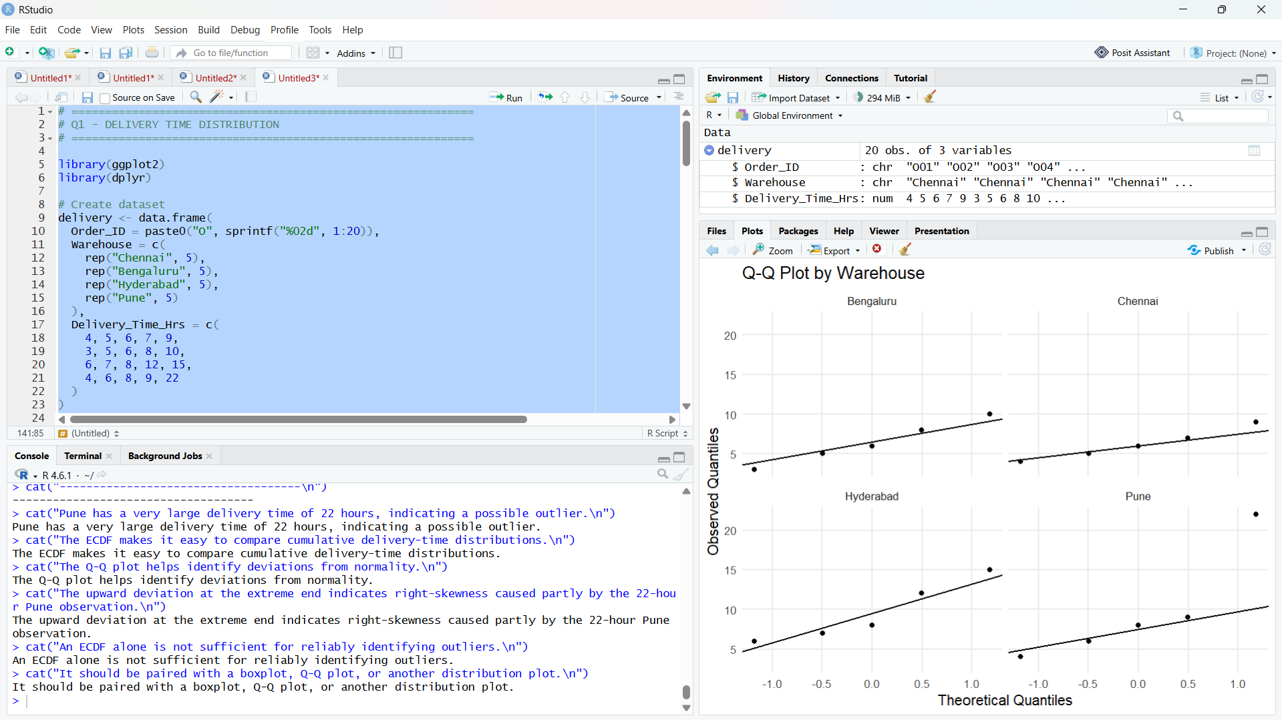

QUESTION 3 – Proportion Visualization
# ============================================================
# Q3 - APP DOWNLOADS
# ============================================================

library(ggplot2)
library(dplyr)

downloads <- data.frame(
City = c(
"Chennai", "Chennai", "Chennai",
"Mumbai", "Mumbai", "Mumbai",
"Delhi", "Delhi", "Delhi",
"Kolkata", "Kolkata", "Kolkata"
),
App_Category = rep(
c("Games", "Social", "Utility"),
4
),
Downloads = c(
30, 42, 18,
35, 38, 22,
26, 44, 20,
24, 36, 29
)
)

print(downloads)

# ------------------------------------------------------------
# 3A. ORIGINAL-STYLE PIE CHARTS
# ------------------------------------------------------------

par(mfrow = c(2, 2))

city_names <- unique(downloads$City)

for (city in city_names) {

temp <- subset(downloads, City == city)

pie(
temp$Downloads,
labels = paste0(
temp$App_Category,
"\n",
temp$Downloads
),
main = paste(city, "App Downloads"),
explode = c(0.08, 0, 0.05)
)
}

par(mfrow = c(1, 1))

# ------------------------------------------------------------
# 3B. SIDE-BY-SIDE BAR CHART
# ------------------------------------------------------------

ggplot(
downloads,
aes(
x = City,
y = Downloads,
fill = App_Category
)
) +
geom_col(
position = position_dodge(width = 0.8),
width = 0.7
) +
labs(
title = "App Downloads by City and Category",
x = "City",
y = "Downloads",
fill = "App Category"
) +
theme_minimal(base_size = 13) +
theme(
panel.grid.minor = element_blank()
)

# ------------------------------------------------------------
# 3C. CALCULATE PROPORTIONS
# ------------------------------------------------------------

downloads_prop <- downloads %>%
group_by(City) %>%
mutate(
Proportion = Downloads / sum(Downloads)
) %>%
ungroup()

print(downloads_prop)

# ------------------------------------------------------------
# 3D. 100% STACKED BAR CHART
# ------------------------------------------------------------

ggplot(
downloads_prop,
aes(
x = City,
y = Proportion,
fill = App_Category
)
) +
geom_col(
width = 0.7
) +
scale_y_continuous(
labels = function(x) paste0(round(x * 100), "%"),
breaks = seq(0, 1, 0.1)
) +
labs(
title = "Proportion of App Downloads by City",
subtitle = "Each city represents 100% of its downloads",
x = "City",
y = "Proportion",
fill = "App Category"
) +
theme_minimal(base_size = 13) +
theme(
panel.grid.minor = element_blank()
)

# ------------------------------------------------------------
# 3E. ADD PERCENTAGE LABELS
# ------------------------------------------------------------

ggplot(
downloads_prop,
aes(
x = City,
y = Proportion,
fill = App_Category
)
) +
geom_col() +
geom_text(
aes(
label = paste0(round(Proportion * 100), "%")
),
position = position_stack(vjust = 0.5),
size = 4
) +
scale_y_continuous(
labels = function(x) paste0(round(x * 100), "%")
) +
labs(
title = "City-wise App Category Proportions",
x = "City",
y = "Percentage",
fill = "Category"
) +
theme_minimal(base_size = 13) +
theme(
panel.grid.minor = element_blank()
)

# ------------------------------------------------------------
# Q3 INTERPRETATION
# ------------------------------------------------------------

cat("\nQ3 INTERPRETATION\n")
cat("------------------------------------\n")
cat("The side-by-side bar chart is best for comparing absolute download counts.\n")
cat("The 100% stacked bar chart is better for comparing category proportions across cities.\n")
cat("Pie charts make comparisons between similar-sized angles difficult.\n")
cat("Exploded slices visually emphasize categories and may imply importance that is not present in the data.\n")
cat("Mismatched colors across separate pie charts make the same category difficult to track.\n")

QUS 3 OUTPUT:
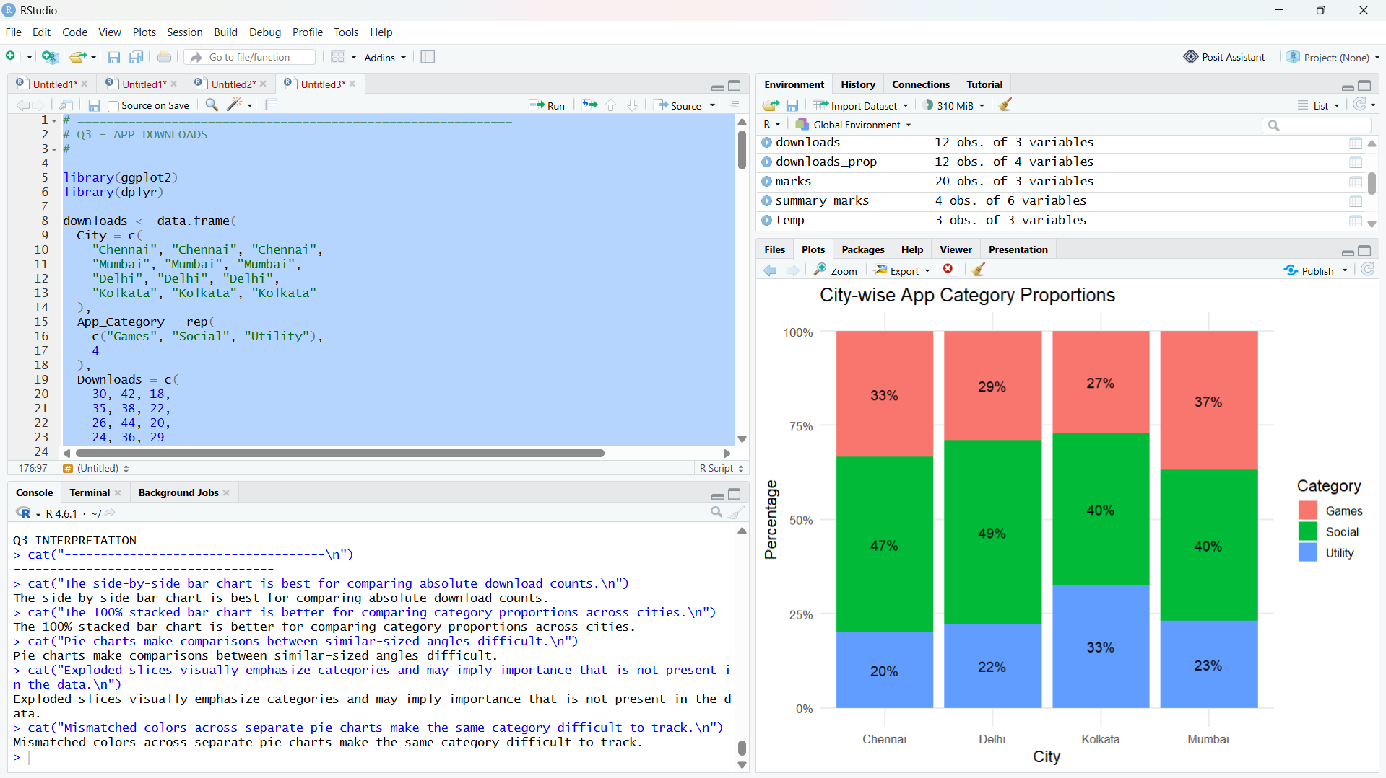

QUESTION 4 – Treemap and Sunburst
# ============================================================
# Q4 - CAMPUS EXPENDITURE
# ============================================================

library(ggplot2)
library(dplyr)
library(treemapify)
library(plotly)

expense <- data.frame(
Campus = c(
"Campus A", "Campus A",
"Campus A", "Campus A",
"Campus B", "Campus B",
"Campus B", "Campus B",
"Campus C", "Campus C",
"Campus C", "Campus C"
),
Department = c(
"Engineering", "Engineering",
"Management", "Management",
"Engineering", "Engineering",
"Management", "Management",
"Engineering", "Engineering",
"Management", "Management"
),
Expense_Type = c(
"Faculty Salary", "Lab Equipment",
"Faculty Salary", "Guest Lectures",
"Faculty Salary", "Lab Equipment",
"Faculty Salary", "Guest Lectures",
"Faculty Salary", "Lab Equipment",
"Faculty Salary", "Guest Lectures"
),
Amount = c(
62000, 34000,
28000, 15000,
54000, 40000,
24000, 17000,
66000, 31000,
26000, 19000
)
)

print(expense)

# ------------------------------------------------------------
# 4A. ORIGINAL TREEMAP
# ------------------------------------------------------------

ggplot(
expense,
aes(
area = Amount,
fill = Department,
label = paste(
Campus,
Department,
Expense_Type,
sep = "\n"
)
)
) +
geom_treemap() +
geom_treemap_text(
colour = "white",
place = "centre",
grow = TRUE
) +
labs(
title = "Original Campus Expenditure Treemap"
) +
theme_minimal()

# ------------------------------------------------------------
# 4B. IMPROVED TREEMAP
# ------------------------------------------------------------

expense <- expense %>%
mutate(
Label = paste0(
Expense_Type,
"\n₹",
format(Amount, big.mark = ",")
)
)

ggplot(
expense,
aes(
area = Amount,
fill = Campus,
label = Label,
subgroup = Department
)
) +
geom_treemap(
colour = "white"
) +
geom_treemap_subgroup_border(
colour = "black",
size = 2
) +
geom_treemap_text(
place = "centre",
grow = TRUE,
reflow = TRUE
) +
labs(
title = "Campus Expenditure by Department and Expense Type",
subtitle = "Area represents expenditure amount; borders indicate departments",
fill = "Campus"
) +
theme_minimal(base_size = 13)

# ------------------------------------------------------------
# 4C. SUMMARY OF EXPENDITURE
# ------------------------------------------------------------

campus_summary <- expense %>%
group_by(Campus) %>%
summarise(
Total_Amount = sum(Amount)
)

print(campus_summary)

department_summary <- expense %>%
group_by(Campus, Department) %>%
summarise(
Total_Amount = sum(Amount),
.groups = "drop"
)

print(department_summary)

# ------------------------------------------------------------
# 4D. SUNBURST
# ------------------------------------------------------------

sunburst_data <- expense %>%
group_by(Campus, Department, Expense_Type) %>%
summarise(
Amount = sum(Amount),
.groups = "drop"
)

fig <- plot_ly(
data = sunburst_data,
ids = ~Expense_Type,
labels = ~Expense_Type,
parents = ~Department,
values = ~Amount,
type = "sunburst",
branchvalues = "total"
)

fig <- fig %>%
layout(
title = "Sunburst: Campus → Department → Expense Type"
)

fig

# ------------------------------------------------------------
# 4E. BETTER SUNBURST WITH UNIQUE HIERARCHY
# ------------------------------------------------------------

sunburst_data2 <- data.frame(
ids = c(
"Campus A",
"Campus A - Engineering",
"A Engineering Faculty Salary",
"A Engineering Lab Equipment",
"Campus A - Management",
"A Management Faculty Salary",
"A Management Guest Lectures",

"Campus B",
"Campus B - Engineering",
"B Engineering Faculty Salary",
"B Engineering Lab Equipment",
"Campus B - Management",
"B Management Faculty Salary",
"B Management Guest Lectures",

"Campus C",
"Campus C - Engineering",
"C Engineering Faculty Salary",
"C Engineering Lab Equipment",
"Campus C - Management",
"C Management Faculty Salary",
"C Management Guest Lectures"
),

labels = c(
"Campus A",
"Engineering",
"Faculty Salary",
"Lab Equipment",
"Management",
"Faculty Salary",
"Guest Lectures",

"Campus B",
"Engineering",
"Faculty Salary",
"Lab Equipment",
"Management",
"Faculty Salary",
"Guest Lectures",

"Campus C",
"Engineering",
"Faculty Salary",
"Lab Equipment",
"Management",
"Faculty Salary",
"Guest Lectures"
),

parents = c(
"",
"Campus A",
"Campus A - Engineering",
"Campus A - Engineering",
"Campus A",
"Campus A - Management",
"Campus A - Management",

"",
"Campus B",
"Campus B - Engineering",
"Campus B - Engineering",
"Campus B",
"Campus B - Management",
"Campus B - Management",

"",
"Campus C",
"Campus C - Engineering",
"Campus C - Engineering",
"Campus C",
"Campus C - Management",
"Campus C - Management"
),

values = c(
139000,
96000,
62000,
34000,
43000,
28000,
15000,

135000,
94000,
54000,
40000,
41000,
24000,
17000,

142000,
97000,
66000,
31000,
45000,
26000,
19000
)
)

fig2 <- plot_ly(
data = sunburst_data2,
ids = ~ids,
labels = ~labels,
parents = ~parents,
values = ~values,
type = "sunburst",
branchvalues = "total"
)

fig2 <- fig2 %>%
layout(
title = "Campus → Department → Expense Type"
)

fig2

# ------------------------------------------------------------
# Q4 INTERPRETATION
# ------------------------------------------------------------

cat("\nQ4 INTERPRETATION\n")
cat("------------------------------------\n")
cat("Treemap area represents expenditure magnitude.\n")
cat("Department boundaries make the hierarchy easier to identify.\n")
cat("Small rectangles can still have limited label space.\n")
cat("The sunburst clearly communicates the hierarchy from campus to department to expense type.\n")
cat("For a board presentation, the improved treemap is recommended because expend

QUS 4 OUTPUT: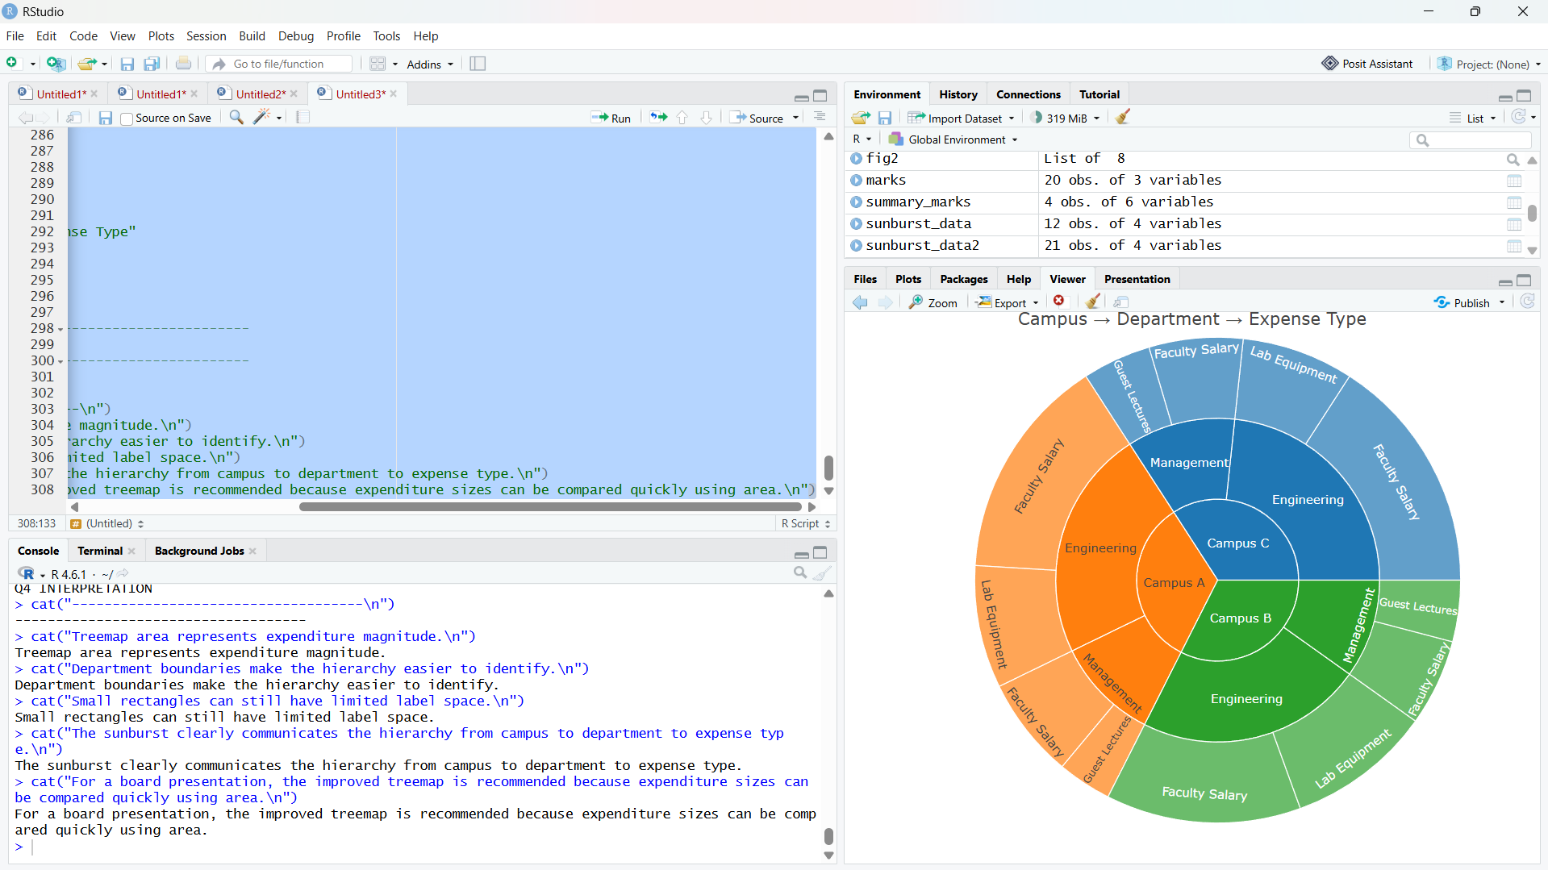

QUESTION 5 – Sankey and Parallel Sets
# ============================================================
# Q5 - COURSE TO CAREER FLOW
# ============================================================

library(dplyr)
library(ggplot2)
library(ggalluvial)
library(networkD3)

career <- data.frame(
Course = c(
"Data Science", "Data Science", "Data Science",
"Web Development", "Web Development", "Web Development",
"Cloud Computing", "Cloud Computing", "Cloud Computing",
"UI/UX Design", "UI/UX Design", "UI/UX Design"
),
Certification = c(
"Yes", "Yes", "No",
"Yes", "Yes", "No",
"Yes", "Yes", "No",
"Yes", "Yes", "No"
),
Job_Role = c(
"Analyst", "Engineer", "Analyst",
"Frontend Dev", "Backend Dev", "Frontend Dev",
"DevOps Engineer", "Cloud Analyst", "Support Engineer",
"Product Designer", "UX Researcher", "Product Designer"
),
Students = c(
22, 14, 9,
19, 11, 7,
17, 10, 6,
13, 8, 5
)
)

print(career)

# ============================================================
# 5A. SANKEY DIAGRAM USING NETWORKD3
# ============================================================

# Create unique nodes
nodes <- data.frame(
name = unique(c(
career$Course,
paste("Certification:", career$Certification),
career$Job_Role
))
)

# Function to obtain node index
get_index <- function(x) {
match(x, nodes$name) - 1
}

# ------------------------------------------------------------
# Course -> Certification flows
# ------------------------------------------------------------

flow1 <- career %>%
group_by(Course, Certification) %>%
summarise(
Students = sum(Students),
.groups = "drop"
) %>%
mutate(
source = get_index(Course),
target = get_index(
paste("Certification:", Certification)
),
value = Students
) %>%
select(source, target, value)

# ------------------------------------------------------------
# Certification -> Job Role flows
# ------------------------------------------------------------

flow2 <- career %>%
group_by(Certification, Job_Role) %>%
summarise(
Students = sum(Students),
.groups = "drop"
) %>%
mutate(
source = get_index(
paste("Certification:", Certification)
),
target = get_index(Job_Role),
value = Students
) %>%
select(source, target, value)

links <- bind_rows(flow1, flow2)

print(nodes)
print(links)

# ------------------------------------------------------------
# ORIGINAL-STYLE SANKEY
# ------------------------------------------------------------

sankeyNetwork(
Links = links,
Nodes = nodes,
Source = "source",
Target = "target",
Value = "value",
NodeID = "name",
fontSize = 12,
nodeWidth = 25,
sinksRight = TRUE
)

# ============================================================
# 5B. IMPROVED SANKEY
# ============================================================

sankeyNetwork(
Links = links,
Nodes = nodes,
Source = "source",
Target = "target",
Value = "value",
NodeID = "name",
fontSize = 14,
nodeWidth = 30,
nodePadding = 15,
sinksRight = TRUE,
width = 1000,
height = 650
)

# ============================================================
# 5C. FLOW SUMMARY
# ============================================================

flow_summary <- career %>%
arrange(desc(Students))

print(flow_summary)

# ============================================================
# 5D. PARALLEL SETS / ALLUVIAL PLOT
# ============================================================

ggplot(
career,
aes(
axis1 = Course,
axis2 = Certification,
axis3 = Job_Role,
y = Students
)
) +
geom_alluvium(
aes(fill = Course),
alpha = 0.7,
width = 1/12
) +
geom_stratum(
width = 1/8,
fill = "grey90",
colour = "black"
) +
geom_text(
stat = "stratum",
aes(label = after_stat(stratum)),
size = 3.5
) +
scale_x_discrete(
limits = c(
"Course",
"Certification",
"Job Role"
),
expand = c(0.05, 0.05)
) +
labs(
title = "Parallel Sets: Course to Career Flow",
subtitle = "Ribbon width represents number of students",
x = NULL,
y = "Number of Students",
fill = "Course"
) +
theme_minimal(base_size = 13) +
theme(
panel.grid = element_blank()
)

# ============================================================
# 5E. PARALLEL SETS WITH CERTIFICATION AS CATEGORY
# ============================================================

career$Certification <- factor(
career$Certification,
levels = c("Yes", "No")
)

ggplot(
career,
aes(
axis1 = Course,
axis2 = Certification,
axis3 = Job_Role,
y = Students
)
) +
geom_alluvium(
aes(fill = Certification),
alpha = 0.7,
width = 1/12
) +
geom_stratum(
width = 1/8,
fill = "grey90",
colour = "black"
) +
geom_text(
stat = "stratum",
aes(label = after_stat(stratum)),
size = 3.5
) +
scale_x_discrete(
limits = c(
"Course",
"Certification",
"Job Role"
)
) +
labs(
title = "Course → Certification → Job Role",
subtitle = "Parallel sets view of student pathways",
x = NULL,
y = "Students",
fill = "Certification"
) +
theme_minimal(base_size = 13) +
theme(
panel.grid = element_blank()
)

# ============================================================
# Q5 INTERPRETATION
# ============================================================

largest_flow <- career %>%
arrange(desc(Students)) %>%
slice(1)

cat("\nQ5 INTERPRETATION\n")
cat("------------------------------------\n")
cat(
"Largest individual career flow:",
largest_flow$Course,
"-> Certification:",
largest_flow$Certification,
"->",
largest_flow$Job_Role,
"with",
largest_flow$Students,
"students.\n"
)

cat("A Sankey diagram is effective for showing flow magnitude and direction.\n")
cat("Meaningful labels and sufficient node spacing reduce confusion.\n")
cat("Parallel sets provide a clearer categorical comparison across multiple dimensions.\n")
cat("Sankey is recommended when the main objective is to communicate major student career flows.\n")
QUS 5 OUTPUT:

